1 рівень

1.

Test was on PC:

Edge (v.139.0.3405.111)

Opera (v.120.0.5543.161)

Yandex (v.25.8.0.1908)

| № | Bug description | Steps | Expected results | Actual results |
| --- | --- | --- | --- | --- |
| 1 | The Logo of Social media "X" is displayed incorrectly on the bottom of the page of the Website | 1. Scroll down to the end of the page |  |  |
| 2 | Clicking on the photo in “Stylists” redirecting to another website instead of giving personal information | 1. Click “Stylists”  2. Click on photo | After click on photo website opens the page with personal information of the person | Redirecting to another website: <https://uk.wix.com/> |
| 3 | The Submenu “Products” work incorrectly | 1. Click “Services”  2. Click on the “left” or “right” arrow | After click on the “left” or “right” arrow image stay on without changing | After click on the “left” or “right” arrow image continue changing |

2.

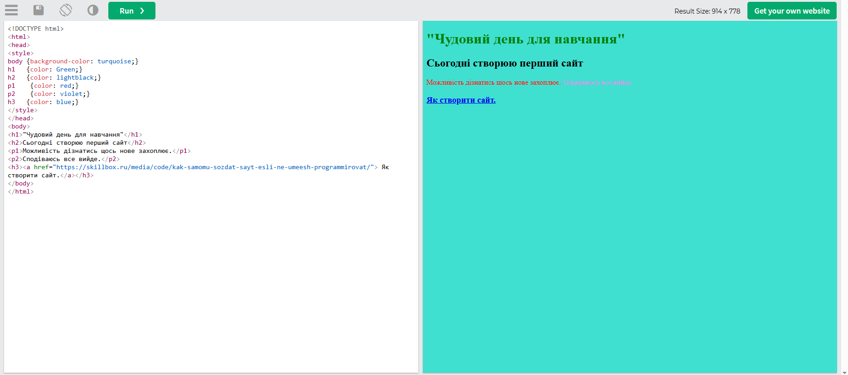

При тестуванні з двох браузерів виявлено різницю між результатами, а саме: у браузері Edge синій колір світліший ніж у Yandex. Лінк переносить на інший сайт без помилок.

Edge (v.139.0.3405.111)

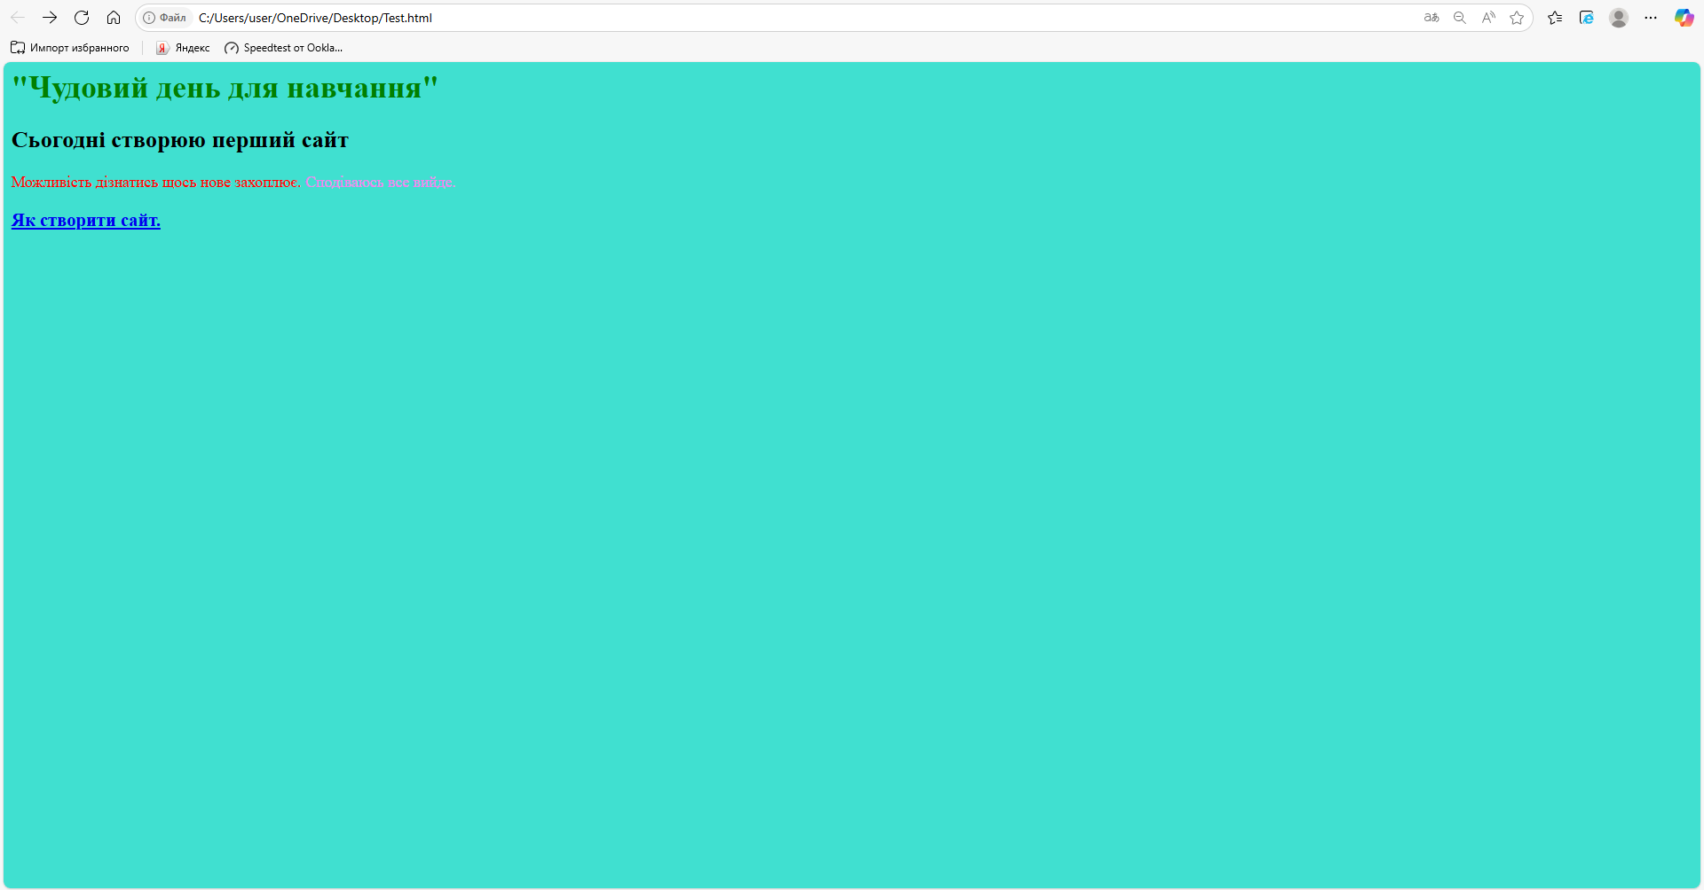

Yandex (v.25.8.0.1908)

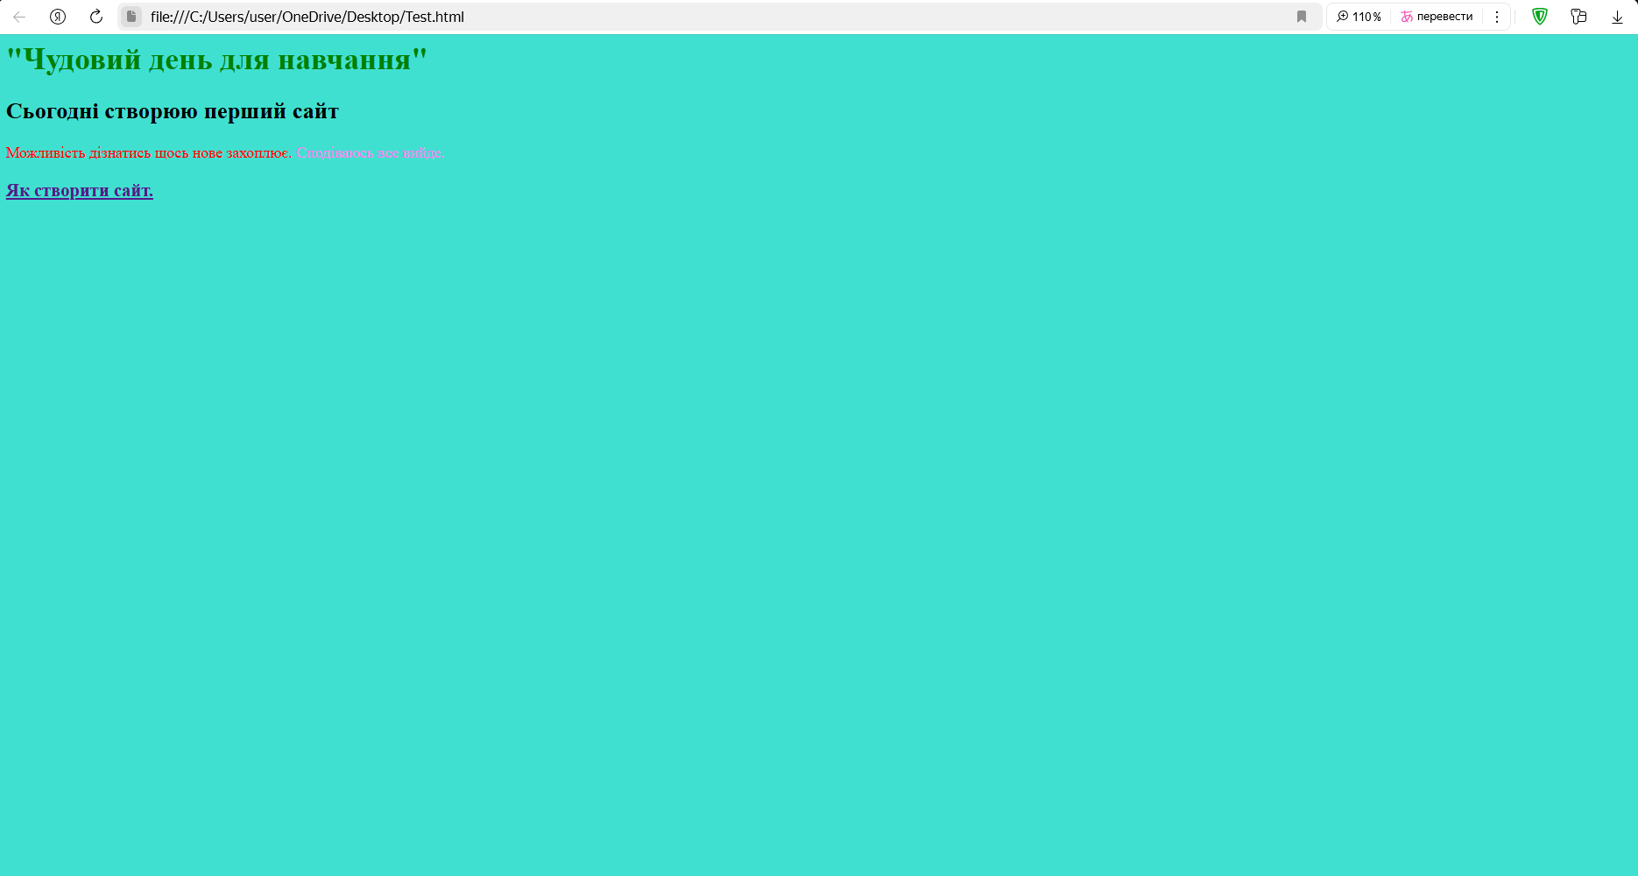

2 рівень

1.

<https://beetroot.academy/> (UTF-8)

<https://microseniors76.com/> (UTF-8)

<https://www.tennis-warehouse.com/> (UTF-8)

<https://www.fidelity.com/> (UTF-8)

